1. **Load MSHI data into Noe4j (mshi, mshi1 and mshi2 files)**

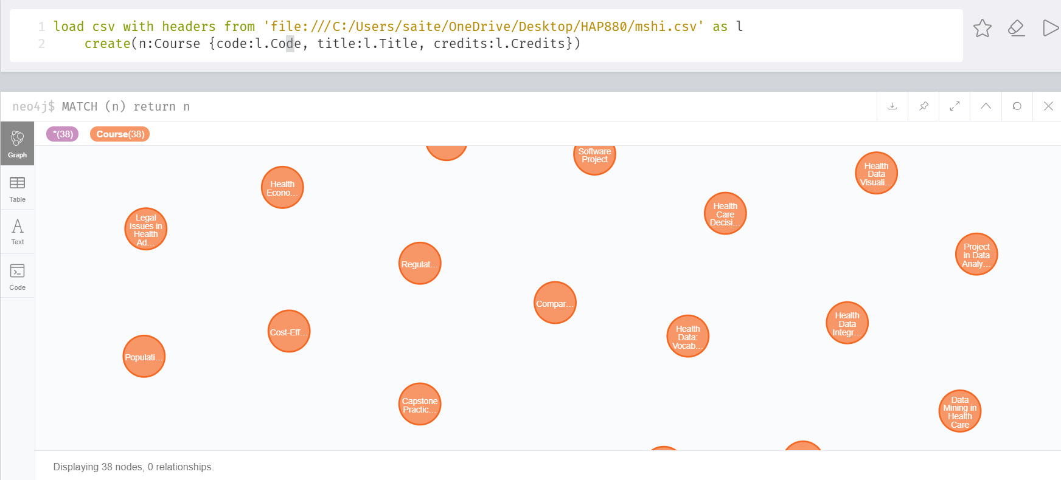

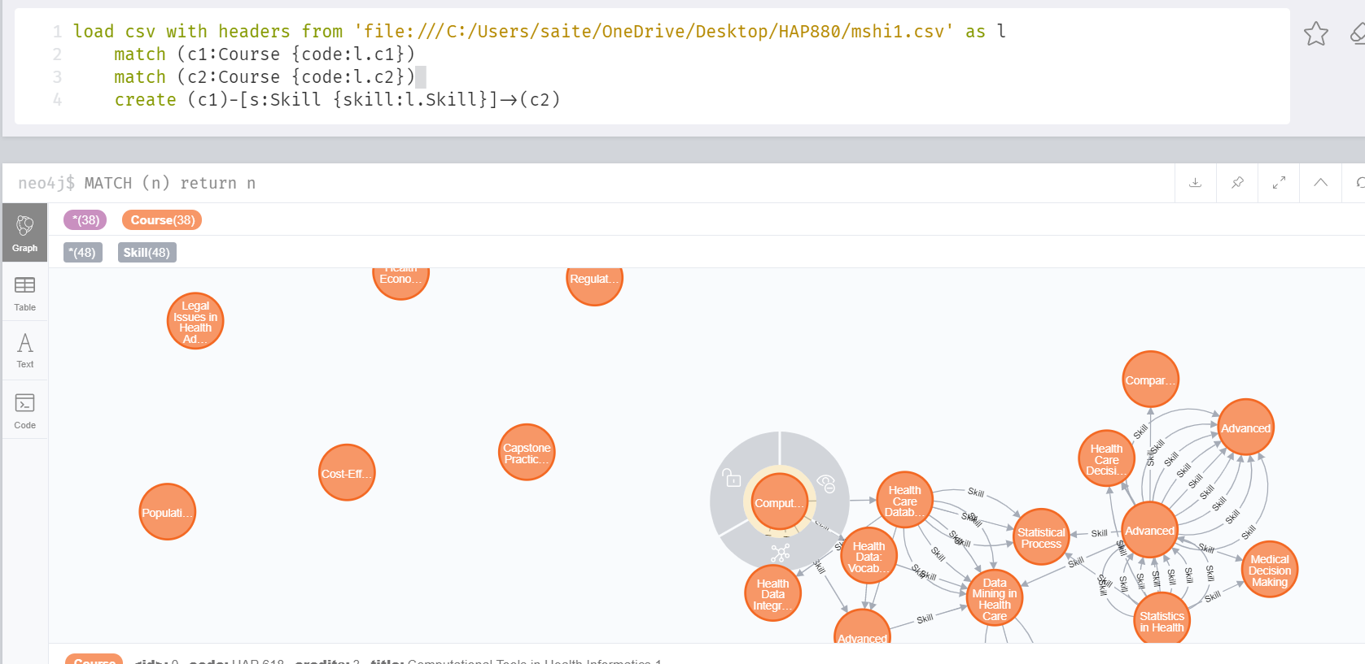

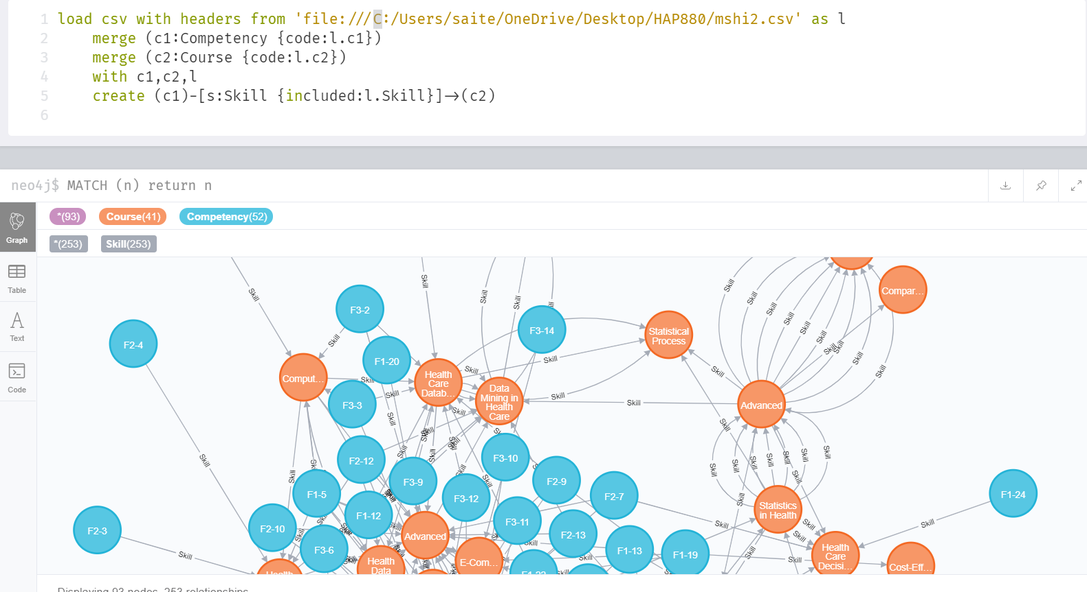

1. **What competencies are covered in HAP 730?**

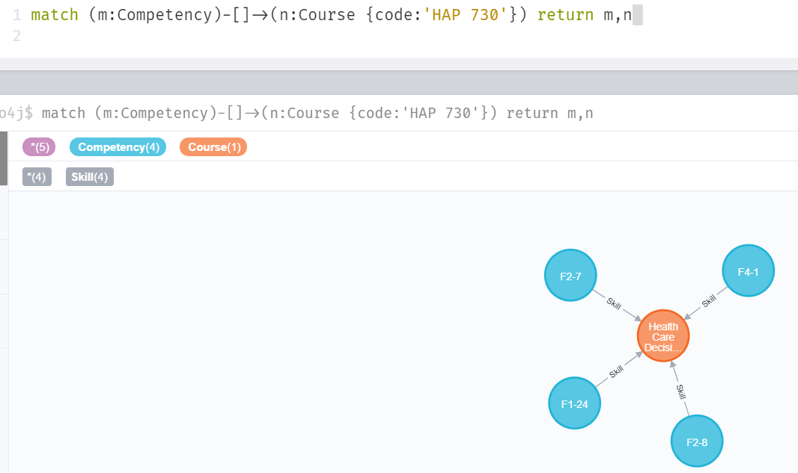

1. **What are prerequisites to HAP 880? List both direct and indirect prerequisites.**

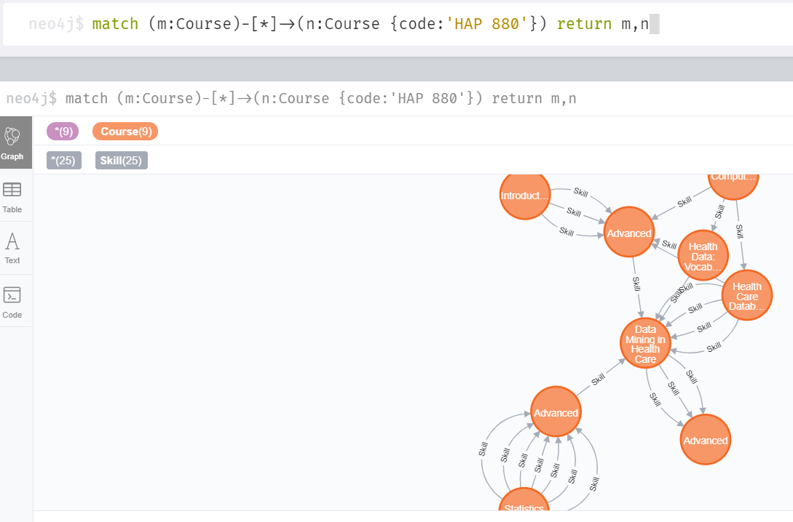

1. **Load hap780 data file on top of the MSHI database, to include all courses but also skills within hap 780. Design appropriate relationships that need to be included to make the graph connected.**

